|  |  |
| --- | --- |
| **YEAR 8** | **Chemical Energy** |

|  |  |
| --- | --- |
| **Learning Intentions** | **Success Criteria** |
| Understand chemical potential energy. | * Describe chemical energy and give examples. * Describe how organisms (such as humans and other animals) gain energy from food. * Read and analyse food energy chats. |

**READ:** *Chemical Energy*

**Chemical energy** is energy stored within a substance. It is a type of potential energy. Examples of chemical energy include food, fuel, wood and batteries.

|  |  |  |  |
| --- | --- | --- | --- |
| <http://clipart-library.com/clipart/139143.htm> | /Users/localadmin/Desktop/XdT4Go7ie.png  <http://clipart-library.com/clipart/XdT4Go7ie.htm> | <http://clipart-library.com/clipart/569911.htm> | <http://clipart-library.com/clipart/1241388.htm> |

**Energy in our Food**

In the **scientific community and in Australia** the energy in our food is measured in **joules** and **kilojoules**.

In **America** energy in food is measured in **calories**. This is similar to the way they measure distance in feet and inches rather than meters and centimetres.

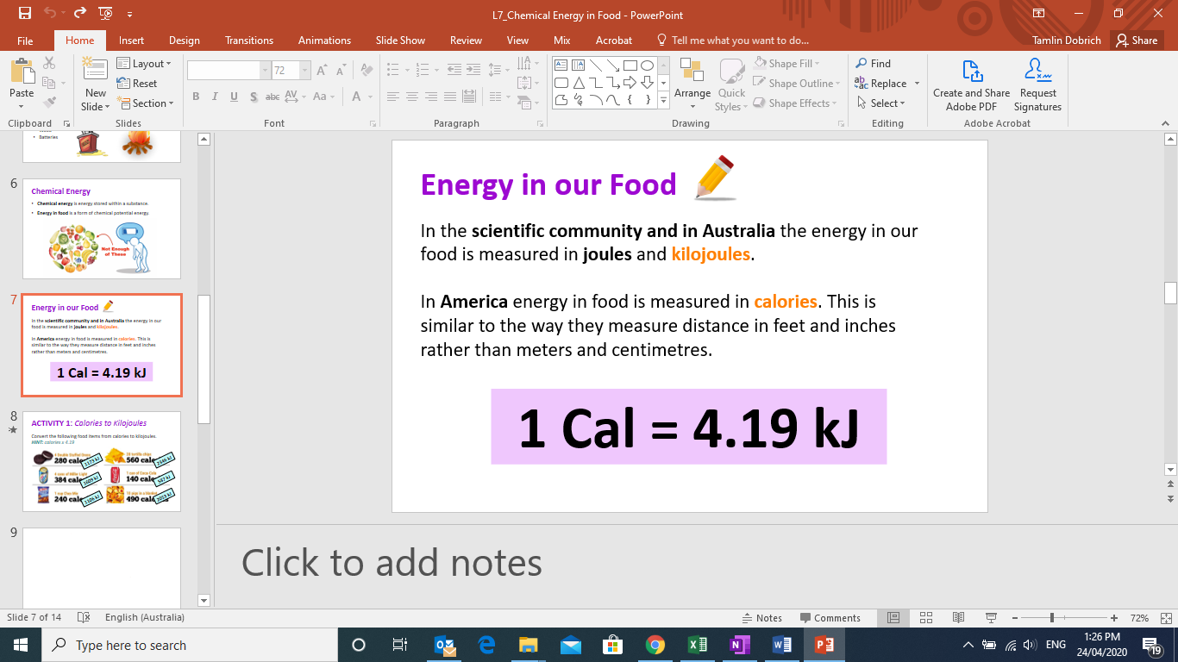

**WATCH:** *How much energy is in your food?*

|  |  |
| --- | --- |
| File:Logo of YouTube (2015-2017).svg - Wikipedia | Watch this YouTube video:  <https://www.youtube.com/watch?v=4ljg7GTMeRU> |

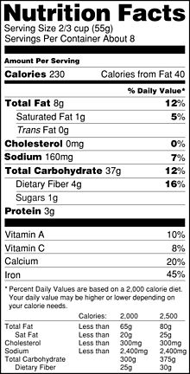**Nutrition Labels**

**Nutrition labels** are labels on foods that tell you about the distribution of nutrient quantities and how much energy they contain.

**QUESTION:** Explain why you think it is important to be able to read nutrition labels.

|  |
| --- |
|  |

**ACTIVITY 1:** *Nando’s Nutrition Labels*

**YOUR TASK:** Analyse the nutrition labels found on food items from Nando’s and complete the questions on the next page.

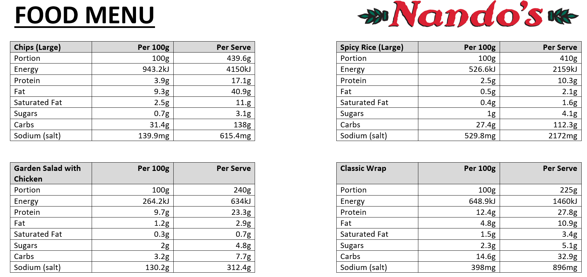

Data: <https://www.fatsecret.com.au/calories-nutrition/search?q=Nando%27s>

**QUESTIONS:** Use the four (4) nutritional information charts provided to analyse the food choices available. Answer the following questions for each.

1. Name the type of energy in food.

|  |
| --- |
|  |

1. State the energy value (per 100g) for each food.

|  |  |
| --- | --- |
| **Food Item** | **Energy Per 100g** |
| Large chips |  |
| Garden salad with chicken |  |
| Large spicy rice |  |
| Classic wrap |  |

1. Order the food options from highest energy to lowest energy, per serve.

|  |
| --- |
| **Highest energy** |
|  |
|  |
|  |
|  |
| **Lowest energy** |

1. Decide which food option is the healthiest choice. Justify your answer. There may be more than one answer.

|  |
| --- |
|  |

**ACTIVITY 2:** *Energy in Your Food*  
 **PART 1: Investigating Food**

**YOUR TASK:** Select your favourite packaged food item from the pantry. Examine the food item and its nutrition label then complete the questions provided.

1. Name the item of food you are investigating.

|  |
| --- |
|  |

1. State the amount of energy per 100g.

|  |
| --- |
|  |

1. State the amount of energy per serving.

|  |
| --- |
|  |

1. Calculate how many servings are there in the whole packet.

|  |
| --- |
|  |

1. Consider the number of servings in this food item, calculate the total amount of energy gained if the whole food item were to be consumed.

|  |
| --- |
|  |

**PART 2: Comparing Food Items**

**YOUR TASK:** Select two (2) new packaged food items from your pantry. Use these to answer the questions below.

1. Select any two food items. Write their names below:

|  |  |
| --- | --- |
| **Item #1** |  |
| **Item #2** |  |

1. State which item has a higher energy value, and the units of energy.

|  |  |
| --- | --- |
| **Per 100g** |  |
| **Per serve** |  |
| **In total** |  |

1. Explain why is it important to compare energy per 100g, rather than per serve.

|  |
| --- |
|  |

1. State which food item you think is healthier. Explain your choice.

|  |
| --- |
|  |

**PART 3: Highest to Lowest**

**YOUR TASK:** Select ten (10) packaged food items from your pantry. Read the food labels for each. Arrange the items from the highest to the lowest energy value per 100g.

|  |
| --- |
| **HIGHEST ENEGRY FOOD (kJ/100g)** |
|  |
|  |
|  |
|  |
|  |
|  |
|  |
|  |
|  |
|  |
| **LOWEST ENERGY FOOD (kJ/100g)** |

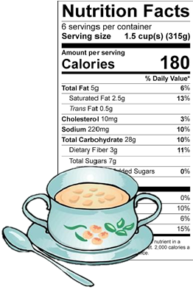**END OF WEEK TEST:** *Chemical Energy*  
 **Question 1**List five examples of stored chemical energy.

|  |  |
| --- | --- |
| **1** |  |
| **2** |  |
| **3** |  |
| **4** |  |
| **5** |  |

**Question 2**

Use the food label shown to answer the following questions   
about potato soup.

1. Calculate how many kilojoules of energy are in each serving of   
   potato soup. *(HINT: 4.19)  
   ________________________________________*
2. If a person ate the whole container of soup, calculate the

chemical energy, in kilojoules they would they receive.   
*________________________________________*Image similar to: <https://extension.umaine.edu/food-health/recipes/kale-white-bean-soup/>

**Question 3**

Create an energy flow diagram that shows how energy from the Sun is transferred to a person running. Include at least three energy changes in your flow diagram.

|  |
| --- |
|  |

Rate your understanding of chemical energy:  
 